**Content**

1. Introduction 2

1. Ansible Terminology 3

1. Introduction

* Ansible is simple open source IT engine which **automates** application **deployment**, intra service **orchestration**, cloud **provisioning** and many other IT tools.
* **Agentless**
* Ansible uses **playbook** to describe automation jobs, and playbook uses very simple language i.e. **YAML**

(The term i.e. is a shortening of the Latin expression id est, which translates to “that is.”)

* Ssh (default), supports Kerberos
* Ansible does not manage one system at time, it models IT infrastructure by describing all of your systems are interrelated.

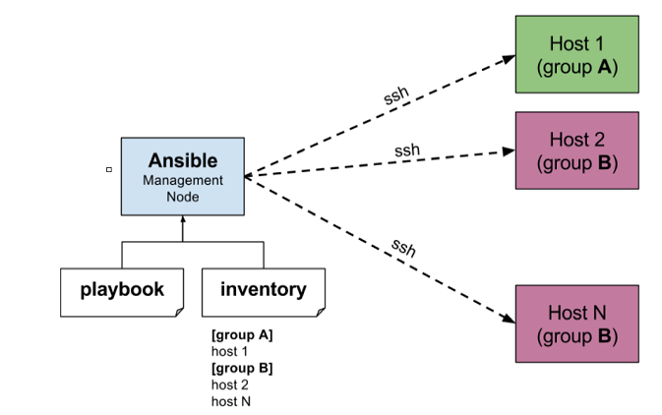The management node controls the entire execution of the playbook. It’s the node from which you are running the installation. The inventory file provides the list of hosts where the Ansible modules needs to be run and the management node does a SSH connection and executes the small modules on the hosts machine and installs the product/software

* **Control machine** − Machine from where we can manage other machines.
* **Remote machine** − Machines which are handled/controlled by control machine.

**Beauty** of Ansible: executes the instructions and if it’s **successfully installed removes the code** which was copied on the host machine which was executed.

Install Python, Ansible. (Windows cannot be control machine)

* 1. Ansible Terminology

**Service/Server** − A process on the machine that provides the service.

**Machine** − A physical server, vm(virtual machine) or a container.

**Target** **machine** − A machine we are about to configure with Ansible.

**Task** − An action(run this, delete that) etc managed by Ansible.

**Playbook** − The yml file where Ansible commands are written and yml is executed on a machine.